EUR-England-Bible Casket,box-17th century

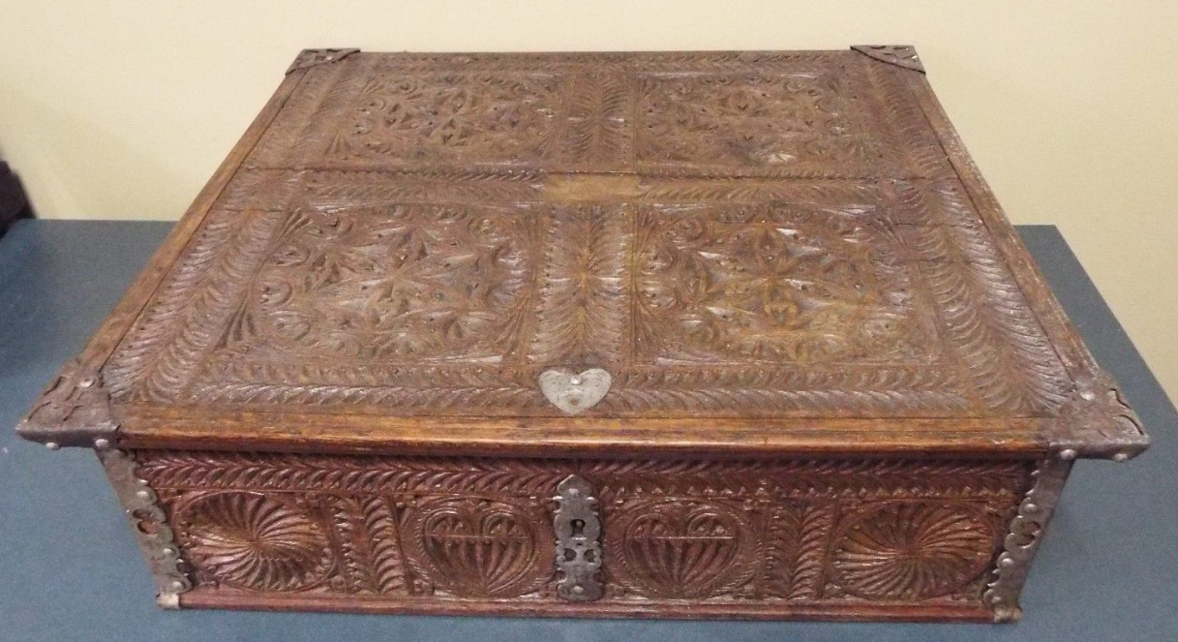 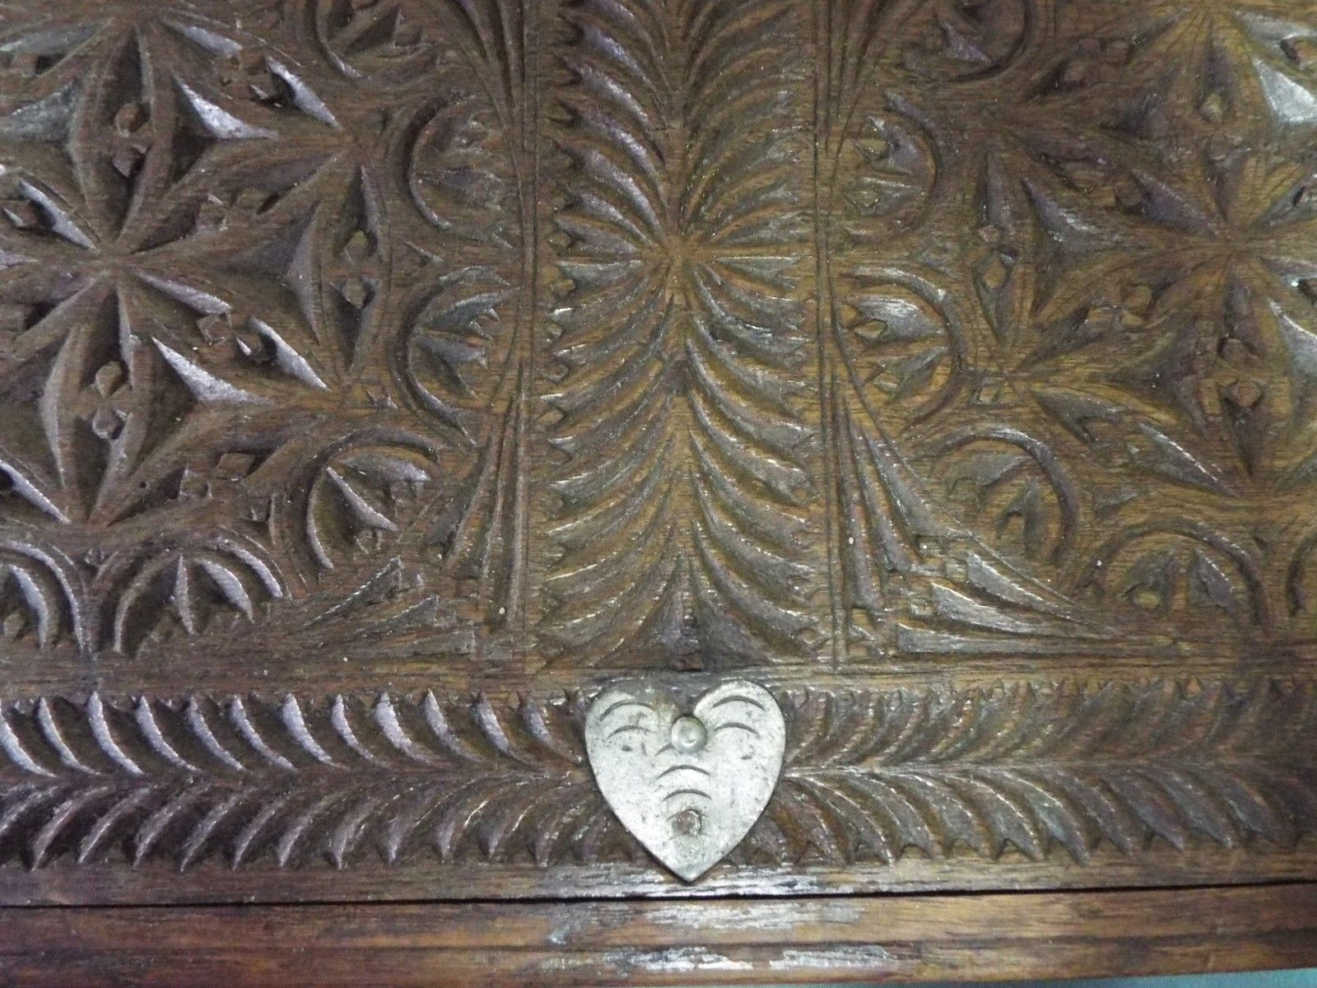 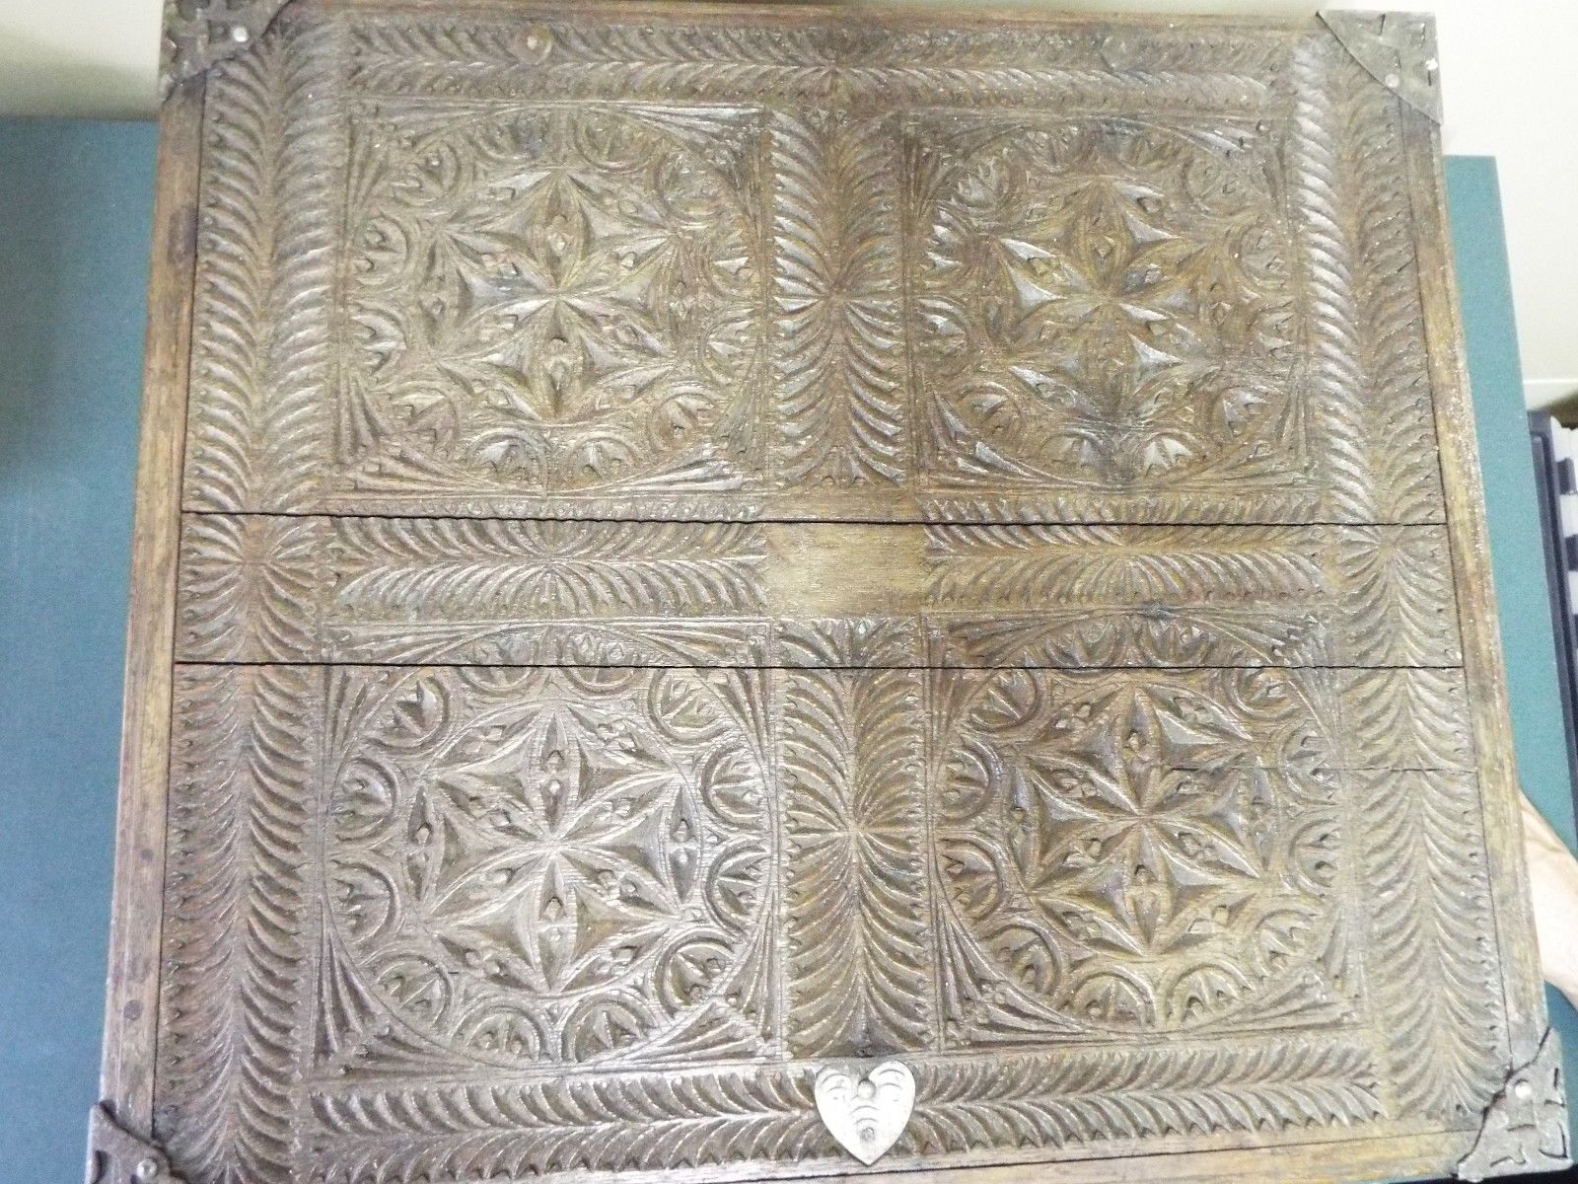 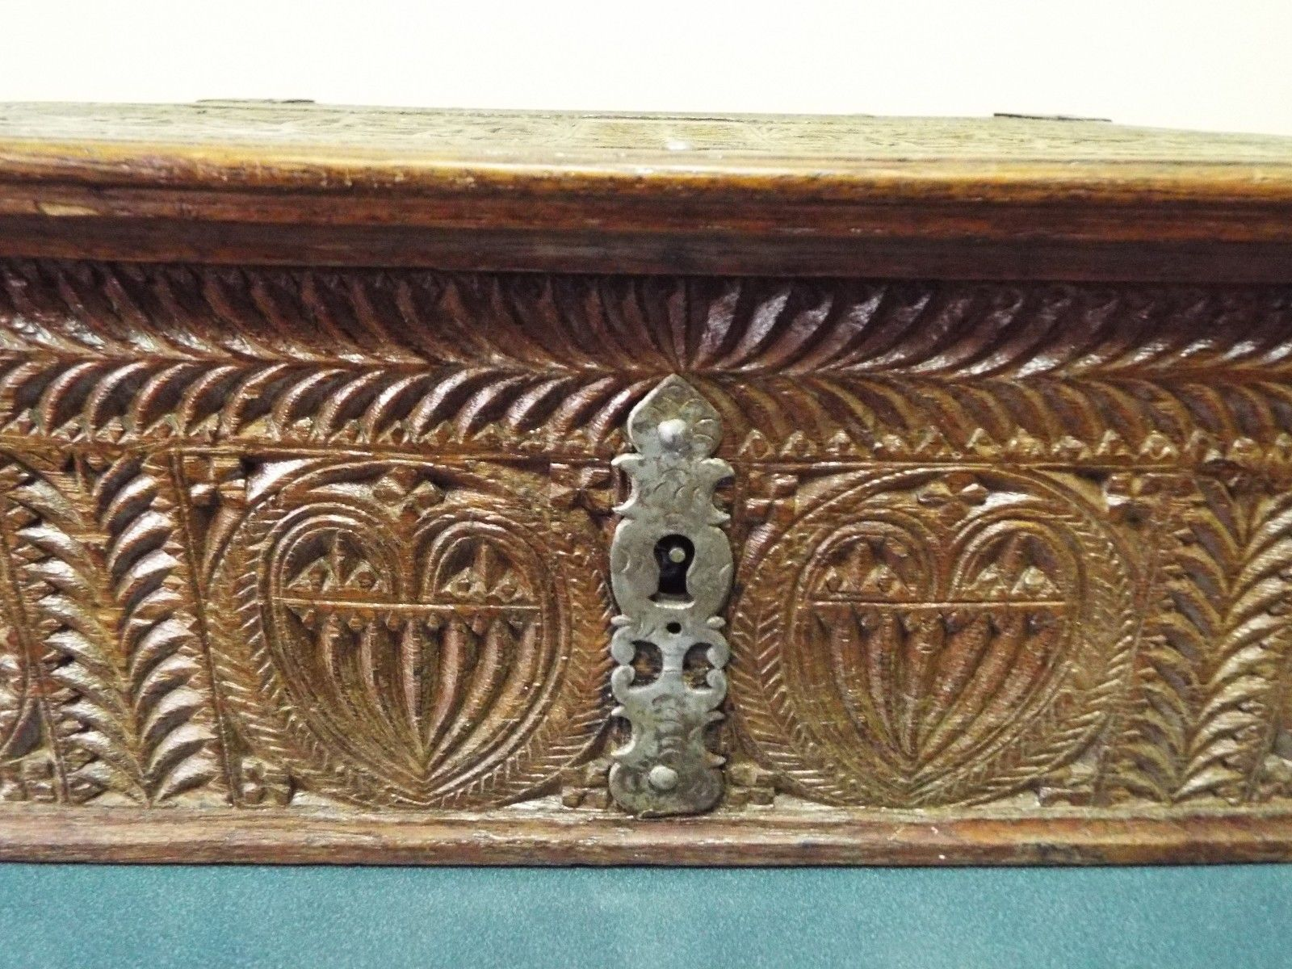 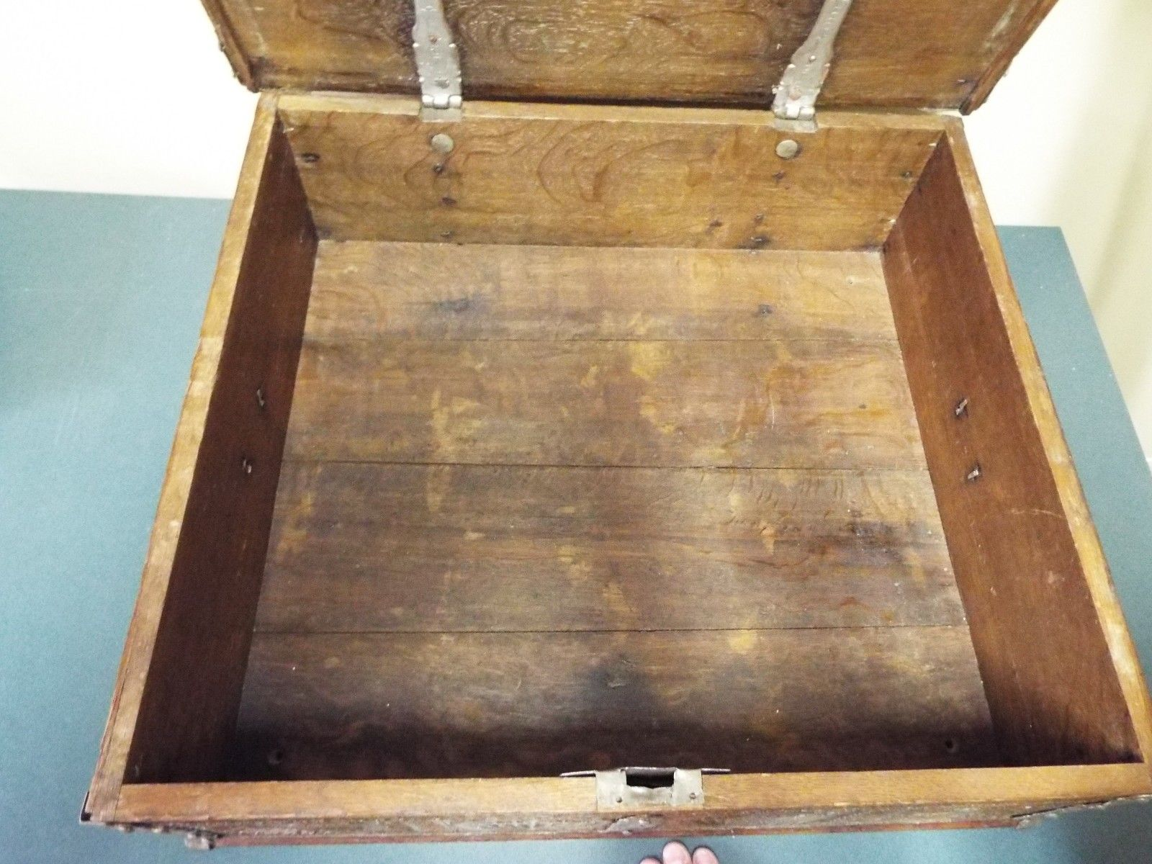

Very fine and rare baroque/renaissance carved oak bible box coffer of the 17th century. The lid and all sides are beautifully carved with a series of rosettes. All wooden parts are original. Stunning baroque style iron fittings and hinges with heart motif decorations (perhaps made as a wedding gift). The lock is probably not original, and the key is missing. Otherwise in good overall condition for its age. Measures at 22.75" x 20.25" x 6.75". This kind of lockable boxes were used to the storage of books and valuables.

**RareBiblesandMore**   
**US $995.00**

[rarebiblesandmore](http://www.ebay.ca/usr/rarebiblesandmore?_trksid=p2047675.l2559) ([1684](http://feedback.ebay.ca/ws/eBayISAPI.dll?ViewFeedback&userid=rarebiblesandmore&iid=252617176971&ssPageName=VIP:feedback&ftab=FeedbackAsSeller&rt=nc&_trksid=p2047675.l2560)

SEE ALSO

Marhamchurch Antiques, dealer in 15th century, 16th century, 17th century, English oak and country furniture and works of art, ranging from the Tudor, Henry VIII, Elizabethan and Jacobean periods.

Refectory tables, coffers, chests, boxes, wainscot chairs, joint stools, tester beds, candlesticks, alms dishes, portraits, and early oak carvings.

Based on the outskirts of Exeter, Devon

*Paul Fitzsimmons  
Marhamchurch Antiques  
Gorwyn House  
Cheriton Bishop  
Exeter  
Devon  
EX6 6JL*

Telephone:   
+44 (0)1647 272 723   
+44 (0)777 903 8891

Email: [**earlyoak@btinternet.com**](mailto:earlyoak@btinternet.com)